# 3 LABORATORINIS DARBAS

## 1. Evaluate the preceding PL/SQL block and determine the data type and value of each of the following variables according to the rules of scoping.

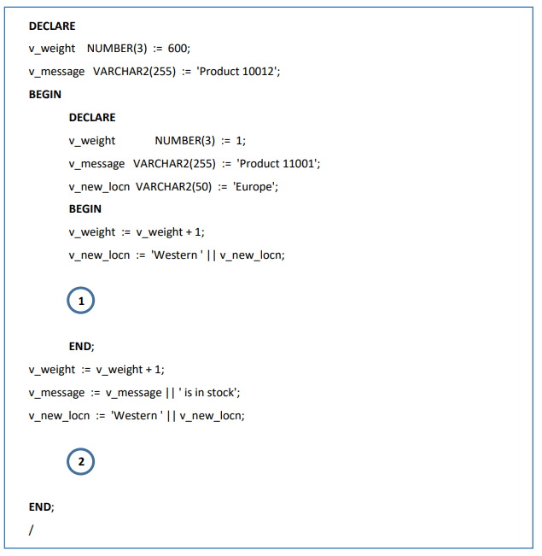

a) The value of v_weight at position 1 is: **2**

b) The value of v_new_locn at position 1 is: **Western Europe**

c) The value of v_weight at position 2 is: **601**

d) The value of v_message at position 2 is: **Product 10012is in stock**

e) The value of v_new_locn at position 2 is: ***Error, not declared***

### 2. In the preceding PL/SQL block, determine the values and data types for each of the following cases.

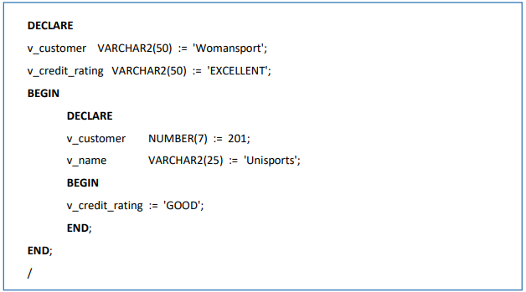

a) The value of v_customer in the nested block is: **201**

b) The value of v_name in the nested block is: **Unisports**

c) The value of v_credit_rating in the nested block is: **GOOD**

d) The value of v_customer in the main block is: **Womansport**

e) The value of v_name in the main block is: ***Error, not declared***

f) The value of v_credit_rating in the main block is: **GOOD**